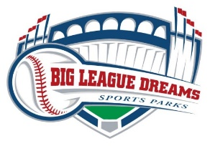

Park closed for Holidays

Big League Dreams Las Vegas will be closed from Wednesday 12/22 through Saturday 1/1. League resumes on Sunday 1/2.
Your division schedule will show future game times.

Happy Holidays
Thank you

